1.

let alphabet={a,b},L=aMbN,where M>N+1,

after chop L,

we can get chop(L) =aN bN by X=aN,Y=aM-N,Z=aN

for chop(L)=aNbN

let P as constant of pumping lamma

choose w=aP bP ,w∈chop(L),|w|=2p>p

let w=xyz with|y|>0,|xy|<=P

Then y must be aJ that 1<=J<=P

choose i=2

w2=xyyz=aP+JbP∉chop(L)

so chop(L) is not regular

2.

(1) 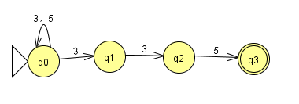

(2)

NFA

3 5

q0 {q0,q1} {q0}

q1 {q2} ∅

q2 ∅ {q3}

q3 ∅ ∅

DFA

3 5

q0 q0q1 q0

q0q1 q0q1q2 q0

q0q1q2 q0q1q2 q0q3

q0q3 q0q1 q0

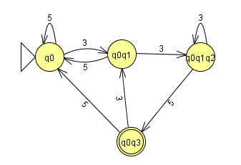

3.

L = ( first (L)·second(L)·third(L)·fourth(L) ·fifth(L))\*

If L is regular ,then first (L)·second(L)·third(L)·fourth(L) ·fifth(L) is regular,

then fifth(L) is regular cause theorem:the class of regular languages is closed under concatenation

4.

(a) regular

NFA OF IT

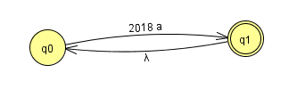

(b)not regular

let M be constant of pumping lamma

choose W=a^(2018^m),|w|=2018^m>m

let W=xyz, with|y|>0,|xy|<=P

with y =a^j,1<=j<=m

let i=2,xyyz=a^(2018^m)\*a^j=a^(2018^m+j)

then a^(2018^m+j)∉ a^(2018^n)

cause 2018m<2018m+j<=2018m+m<2018m+2018m<2018^m+2017\*2018^m=2018m+1

so its not regular

5.(a)let M be the constant of pumping lamma

choose W=am bcm,|W|=2M+1>M

let W=xyz,with |y|>0,|xy|<=M

then y must be aJ with 1<=J<=M

let i=2,W2=xyyz=a(M+J)bcM

cause J>=1,M+J≠M

W2∉L,contradiction

so,L is not regular

(b)

(1)

step1.when n=0,LHS=2^n=1,RHS=2n=0,LHS>=RHS,true

step 2,assume when n=x with x>=1,2^x>=2x

step3,2^(x+1)=2^x+2^x>=2x+2x>=2(x+1), LHS>=RHS,true

so 2n>=2n

f(m+1)=2^f(m)>=2f(m)

(2)

step 1,when n=0,LHS=1,RHS=0,LHS>RHS,true

step2, assume when n=x,x>=1,f(x)>x

step3,f(x+1)=2^x>=2x //proved by (b.1)

2x>=x+1= cause x>=1

so f(x+1)>=x+1

so f(n) >=n

(3)

let M =constant of pumping lamma

assume W=af(M)  with |W|=f(m)>=m [//proved](file:///\\proved) by (b.2)

let W=xyz,with |y|>0and |xy|<m

y must be a^j,1<=j<=m

let i=2,W2=xyyz=af(M)\*aj

f(M)<f(M)+j<=f(M)+M<f(M)+f(M)//proved by B.2)<=F(M+1)//proved by (B.1)

so W2 ∉L, contradicition

so L is not regular

6.G=({S},(a,b),S,P)

P is

S->aaaaaS

S->aaaabS

S->aaabaS

S->aabaaS

S->abaaaS

S->baaaaS

S->bbaaaS

S->babaaS

S->baabaS

S->baaabS

S->abbaaS

S->ababaS

S->abaabS

S->aabbaS

S->aababS

S->aaabbS

S->aabbbS

S->ababbS

S->abbabS

S->abbbaS

S->baabbS

S->bababS

S->babbaS

S->bbaabS

S->bbabaS

S->bbbaaS

S->abbbbS

S->babbbS

S->bbabbS

S->bbbabS

S->bbbbaS

S->bbbbbS

S->*λ*

（b）G=({S,A,B,C,D,E},(a,b),S,P)

P is

S->bS|A

A->aA|B

B->abC

C->bC|D

D->aD|E

E->abS|*λ*

7.

（a）

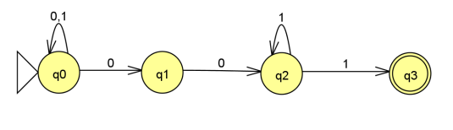

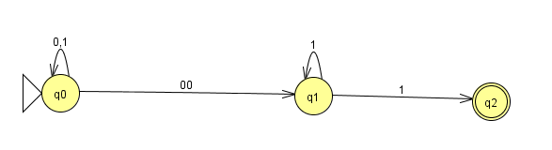

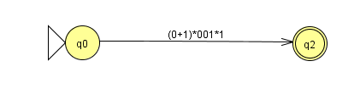

=(0+1)\*001\*1

(2)

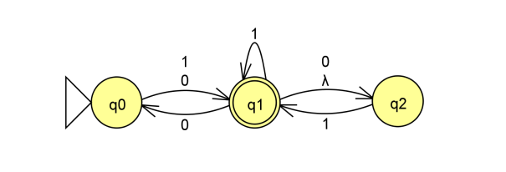

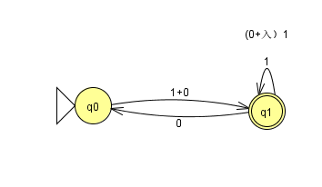

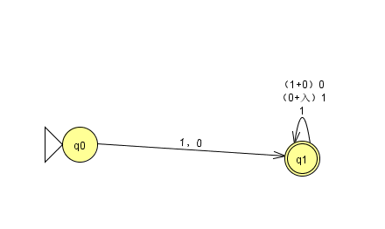

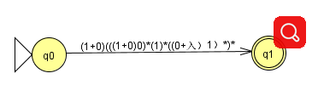

=(1+0)(((1+0)0)\* (1)\* ((0+*λ*)1)\*)\*